**TO:** Deans, Associate Deans

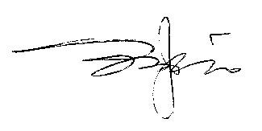

**FROM:** Jianping Zhu, Ph.D., Dean

College of Graduate Studies

**DATE:** January 17, 2013

It has been brought to the Graduate Council’s attention that some CSU graduate programs offer or plan to offer graduate courses that are cross listed with undergraduate courses across more than one level. Graduate Council members strongly feel that the listing of courses across more than one level, for example, 300/500 or 400/600, does not reflect positively on the quality of our graduate courses. As such, the Graduate Council or the College of Graduate Studies will not approve such cross listing in the future unless there is a compelling justification.